**MID TERM ONE EXAMINATIONS -2023**

**BABY CLASS**

Mathematical concepts

My name is_________________

I am __________old

1. Shade the given numbers
2. Trace the numbers 1-4

1. Copy and write

|  |  |  |  |  |  |  |  |  |  |
| --- | --- | --- | --- | --- | --- | --- | --- | --- | --- |
| 1 | 2 | 3 | 4 | 5 | 6 | 7 | 8 | 9 | 10 |
|  |  |  |  |  |  |  |  |  |  |

1. Match and write the numbers
2. 5**___**
3. 3**___**
4. 2**___**
5. 1**___**
6. 4**___**
7. Count and Circle

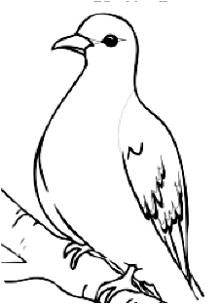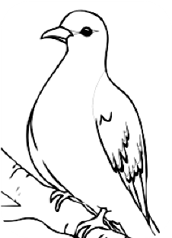

2 1 3

1 2 3

1 2 3

1. Count and write.

= ______ =_______

= ______ = ______

1. Copy the same

